ADKOM

12th International Conference

The future of the utility sector

11 –13.June 2025
Metropol Lake Resort-Ohrid

Hotel: | Room type: | 11-13.06 | 12-13.06 | 11-14.06 | 12-14.06
* * * *  Metropol / Bellevue | single | 200€ | 115€ | 285€ | 200€
* * * *  Metropol / Bellevue | double | 312€ | 186€ | 438€ | 312€
 | triple | 420€ | 255€ | 594€ | 420€
* The rates are per room , per dates

HOTEL RESERVATION FORM:
Hotel: |  | Date (from-to):
Room type:
Name:
Company
Tel./ E-mail:

Payment: 1) Online payment or bank transfer prior arrival 2) At reception desk, after arrival

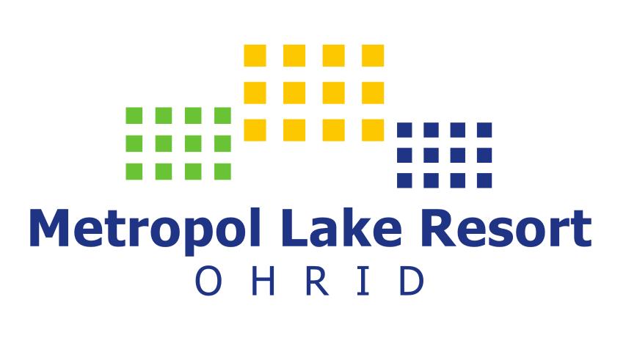

Please send this form latest by 01.June, 2025
Reservation Department, Metropol Lake Resort - Ohrid

Phone +389 46 277 660, +389 46 203 001
sales@metropol-ohrid.com.mk

